employee database: user manual

The purpose of the employee database is for a human resources manager to manage employee information in a company. The functions allowed in this program are: adding, editing, and removing employees, searching for employees by employee number, and displaying employee information.

There are two types of employees – part-time and full-time. There will be different methods of calculating income for these different employees.

1. startup

Upon opening a new instance of the employee database, the following will be seen:

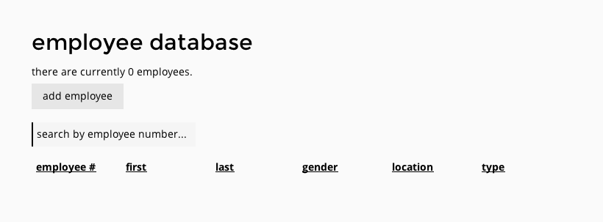

*The first time opening the employee database.*

The number of employees will be indicated at the top (currently 0), along with a button to add employees. Clicking on this button will open up a new panel to the side to enter information for the new employee.

Underneath this button is an input to search for employees by employee number; further below is a table displaying the current employees in the system (currently empty).

2. adding employees

Clicking on the “add employee” button will bring up a new panel: the employee information editor. It looks something like this:

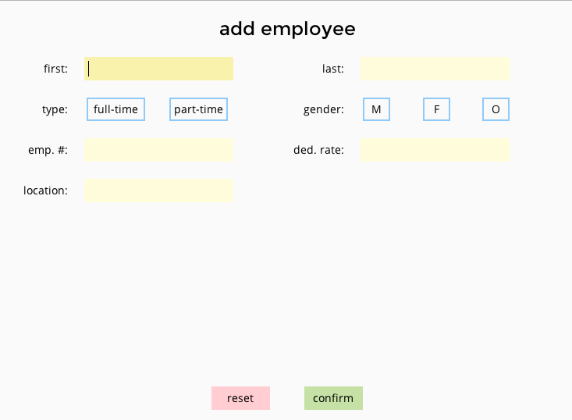

*The initial view of the employee information editor.*

A few input fields can be seen: first name (first), last name (last), employee type (type), employee gender (gender), employee number (emp. #), deductions rate (ded. rate), and work location (location). These fields will be required for both types of employees; after choosing a type, additional fields will appear below. For full-time employees, an input will appear for the yearly salary (salary). Part-time employees will have three new fields: hourly wage (wage), hours worked in a week (hours), and weeks worked in a year (weeks).

The confirm button will add the new employee to the system if all inputs are correct. These changes will be automatically updated in the main dashboard. After successfully adding the employee, the inputs will be reset.

The reset button will reset all the information in the editor.

2.1 navigation in the editor panel

Although clicking on different fields to select them will work, keyboard shortcuts are often much faster for data entry. The cursor will be focused on the first name field upon entry; this is where the *focus* is.

This *focus* can be moved by pressing the “tab” key on the keyboard to move forward one field, and pressing “shift + tab” will move the focus to the previous field. In addition to this, pressing the “enter” key will move the focus to the next field as well. In this manner, the use can simply type in the desired information in the current field and press “enter” to continue. The enter key will also select the highlighted button on selection fields (before moving on to the next field), such as the employee type and gender.



*“part-time” is in focus (highlighted); pressing enter will select the part-time employee. Pressing enter will move the focus to “M” of the gender field.*

Using keyboard shortcuts and moving the focus will allow the user to progress until the focus reaches the “confirm” button. Pressing enter at this point will add the new employee to the system.

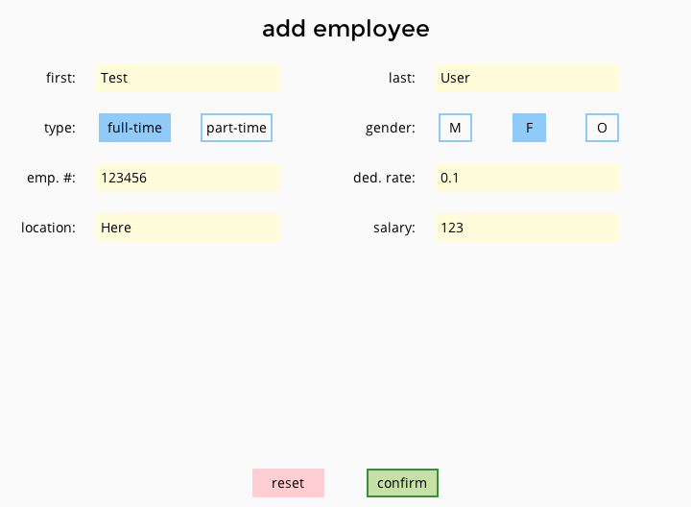

*A completed full-time employee. The focus is on the confirm button.*

Experienced users will notice that pressing “tab” will cycle the focus back to the first name field; ignoring the reset button. However, pressing “shift + tab” on the first name field will bring the focus to the last element, the reset button. This is intentional to prevent accidentally erasing information.

3. errors

There may be error notifications when adding a new employee. Caution signs will appear beside erroneous inputs and an error message will appear at the bottom explaining one of the errors. As the inputs are fixed, the error messages will change to reflect the updates.

The employee will not be added if there are errors in the inputs.

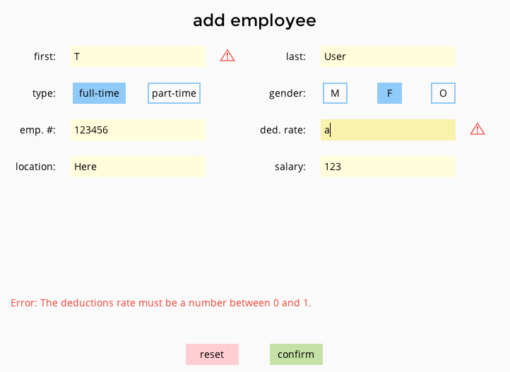

*Errors in the inputs. The deductions error is currently being explained.*

4. viewing employee information